SCHEDULE A

FINAL ANNUAL BUDGET AND SUPPORTING DOCUMENTATION FOR CHRIS HANI DISTRICT MUNICIPALITY

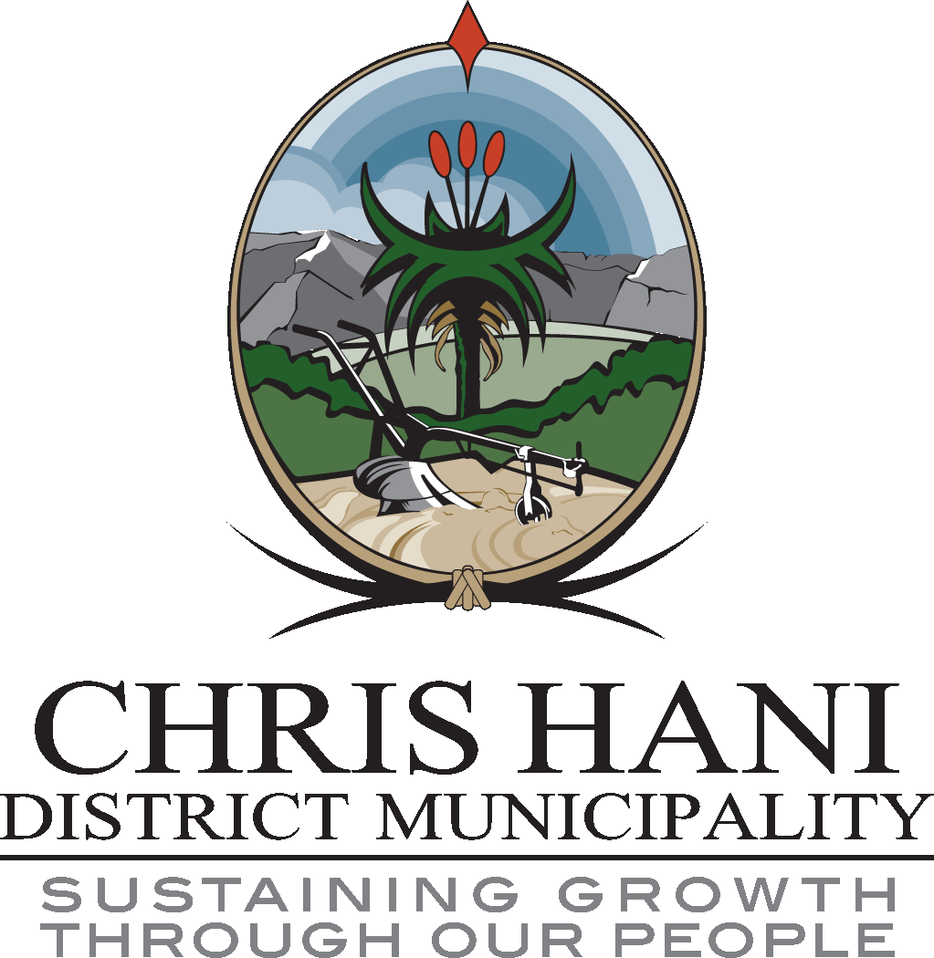

FINAL ANNUAL BUDGET OF  
CHRIS HANI DISTRICT MUNICIPALITY

2020/21 TO 2022/23  
MEDIUM TERM REVENUE AND EXPENDITURE FRAMEWORK

Table of Contents

1.1 Executive Summary 3

Table 1 Consolidated Overview of the 2020/21 MTREF 3

1.2 Operating Revenue Framework 4

Table 1 Summary of revenue classified by main revenue source

Table 3 Percentage growth in revenue by main revenue source 6

Table 4 Operating Transfers and Grant Receipts 9

1.2.1 Sale of Water and Impact of Tariff Increases 10

1.3 Operating Expenditure Framework 11

Table 5 Summary of operating expenditure by standard classification item 12

Figure 1 Main operational expenditure categories for the 2020/21 financial year 15

1.3.1 Free Basic Services: Indigent Support 15

1.4 Capital expenditure 17

Table 6 2020/21 Medium-term capital budget per vote 17

1.5 Annual Budget Tables - Parent Municipality 18

Table 7 MBRR Table A1 - Budget Summary

Table 8 MBRR Table A2 - Budgeted Financial Performance (revenue and expenditure by standard classification) **Error! Bookmark not defined.**

Table 9 MBRR Table A3 - Budgeted Financial Performance (revenue and expenditure by municipal vote) **Error! Bookmark not defined.**

Table 10 Surplus/ (Deficit) calculations for the trading services **Error! Bookmark not defined.**

Table 11 MBRR Table A4 - Budgeted Financial Performance (revenue and expenditure) 20

Table 12 MBRR Table A5 - Budgeted Capital Expenditure by vote, standard classification and funding source 23

Table 13 MBRR Table A6 - Budgeted Financial Position 24

Table 14 MBRR Table A7 - Budgeted Cash Flow Statement 27

Table 15 MBRR Table A8 - Cash Backed Reserves/Accumulated Surplus Reconciliation 27

## Executive Summary

In terms of section 227 of the Constitution, local government is entitled to an equitable share of nationally raised revenue to enable it to provide basic services and perform its allocated functions. The local government equitable share is an unconditional transfer that supplements the revenue raised by municipalities (including property rates and service charges). The equitable share provides funding for municipalities to deliver free basic services to poor households and subsidises the cost of administration and other core services for those municipalities that have the least potential to cover these.

The Constitution gives local government substantial own-revenue-raising powers (particularly through property rates and surcharges on services). Municipalities are expected to fund most of their own administrative costs and cross-subsidise some services for indigent residents. The budget must indicate all allocations from its equitable share and conditional allocations to be transferred to the municipality indicating each category of funding to be utilised by the municipality in the provision of services.

In view of the aforementioned, the following table is a consolidated overview of the proposed 2020/21 (MTREF) Medium-term Revenue and Expenditure Framework for Chris Hani District Municipality:

### Table 1 Consolidated Overview of the 2020/21 MTREF:-



Total operating revenue has declined by 3.3 % to R 1.143 billion for the 2020/21 financial year when compared to the 2019/20 second adjustment budget. For the two outer years, operating revenue will increase by 2 % and 8 % respectively.

Total operating expenditure for the 2020/21 financial year has been appropriated at R 1,044 billion and translates into a budgeted operating surplus of R 98.6 million, when compared to the 2019/20 second adjustment budget, operational expenditure has decreased by 7.8 % in the 2020/21 final budget and has increased by 0.5 % and 8.1 % in 2021/22 and 2022/23 respectively. The operating surplus for the two outer years drastically increases from R 98.6 million in the current budget year to R 117.8 million and R 134.0 million respectively in the two outer years. These low surplus levels indicate that the municipality has to increase own revenue base from the water and sanitation services to sustain the financial stability of the municipality.

The capital budget of R 620.5 million for 2020/21 is 363 % more when compared to the 2019/20 second adjustment budget. The increase is due to the allocations that have increased in the current budget year. The capital programmes are reflecting a gradual decrease in the two outer years to R 569.6 million and R 481.9 million respectively. The main source of capital funding for the municipality are national conditional grants meant to fund infrastructure. The municipality has to devise and fully implement the revenue enhancement strategy to increase it’s revenue base. The cost of maintaining the capital infrastructure has to be funded through revenue generating assets. The municipality has to budget for the maintenance of the infrastructure capital assets to maintain its service delivery potential.

## Operating Revenue Framework:-

For the municipality to continue improving the quality of services provided to its citizens it needs to generate the required own revenue. Strong revenue management is fundamental to the financial sustainability of the district municipality. The reality is that the district is faced with infrastructure backlogs and poverty. The expenditure required to address these challenges will inevitably always exceed available funding; hence the need to determine economic, cost reflective and affordable tariffs and balancing expenditures against realistically anticipated revenues. The municipality has to improve the revenue cycle in order to have funds available to sustain a positive cash flow position and its liquidity.

The municipality has embarked on data cleansing activities which will improve billing and debt collection rate. The focus areas of this strategy are to improve and enhance the following:-

* The indigent registration;
* Data cleansing on the financial information systems;
* Updating of all consumer files data;
* Accurate billing (proper tariffs charged);
* Revenue collection that’s sustains the cash flow position of the municipality;
* Skills transfer and capacitation of Council officials on implementation of the revenue enhancement strategy;
* Debt recovery of outstanding debtors; and
* An effective implementation of the credit control policy.

**The following table is a revenue summary of the 2020/21 MTREF (by revenue source):**

**Table 2: Summary of revenue classified by main revenue source:-**



### Figure 1: Main operating revenue categories for the 2020/21 financial year:-

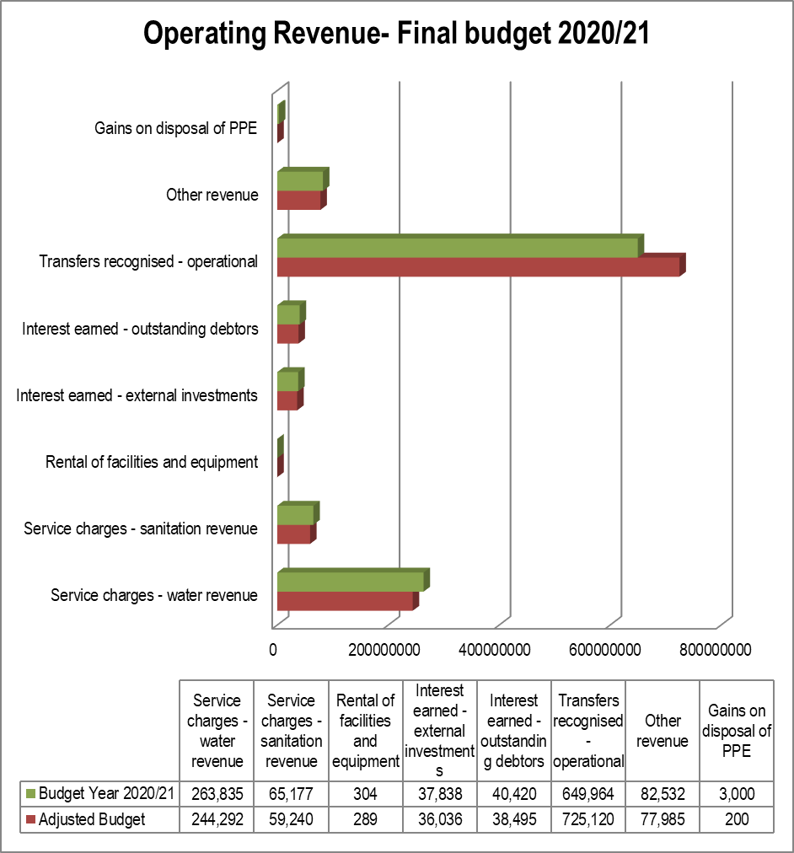

### Table 3: Percentage growth in revenue by main revenue source:-



In line with the formats prescribed by the Municipal Budget and Reporting Regulations, capital transfers and contributions are excluded from the operating statement in order to achieve the correct calculation of the operating surplus/deficit.

Transfers recognised operational which are in fact operating grants, are the main revenue stream and constitute 56.8 % of the total operating revenue of the municipality amounting to R 649.9 million. In 2020/21 financial year, revenue from water services charges was estimated at R 263.8 million or 23.1 % of total operating revenue and sanitation services are R 65.2 million and constitute 5.7 % of the total operating revenue. The water revenue increases to R 269.3 and R 282.8 million in the respective outer financial years of the MTREF. The municipality has projected an annual decrease in revenue at 3 %, and an increase of 2 % and 9 % for the two outer years respectively, and is based on the expected changes in the tariffs charged and improvement in the collection rate and accuracy of billing. An effective revenue enhancement strategy will improve the collection rate of the budgeted revenue by the municipality.

Water and sanitation revenue constitutes 28.7 % of the total operating revenue hence the need for the municipality to focus on the effective implementation of the credit control measures. The municipality is highly grant dependent as mentioned above hence the need to focus on the generation of own revenue for the long term financial sustainability.

**Table 4: Operating Transfers and Grant Receipts:-** 

The table above is a breakdown of grant funding that is allocated to the municipality. This is an indication that, the municipality to be financially viable it mainly depends on grant funding for its operations. As depicted in Supporting Table SA18 above over the MTREF period there is going to be a slight increase in grants allocated to the municipality, this therefore requires the municipality to fully implement strategies to improve on the billing and debt collection of consumer debtors; and the implementation of the cost containment measures to curb unnecessary expenditure.

### Sale of Water and Impact of Tariff Increases:-

The municipality as a Water Services Authority and Provider is currently experiencing problems in the billing process, debt collection and implementation of the applicable water tariffs across the district. National Treasury is encouraging all municipalities to carefully review the level and structure of their water tariffs to ensure, that:

* Water tariffs are fully cost-reflective – including the cost of operating and maintenance of purification plants, water networks and the cost associated with reticulation expansion;
* Tariffs are structured such that they protect basic levels of service and ensure the provision of free services to the indigent; and
* Tariffs are designed to encourage efficient and sustainable consumption.

In addition National Treasury has urged all municipalities to ensure that Tariff structures are cost reflective by 2014 and to date the municipality has missed that deadline, as the cost of providing these services is higher than the billing amount and debt collection rate for the services.

The municipality is a Water Services Authority (WSA) and Provider (WSP), therefore has to realise own revenue from rendering of water and sanitation services. The above allocations are not sufficient to maintain, repair and ensure the sustainability of the water infrastructure assets that should generate a revenue base for the municipality in order to cover operational and capital costs. Attached is **Annexure A**, indicating the breakdown of the tariffs to be implemented in recognising own revenue from water and sanitation services.

The municipality is currently reviewing the level and structure of water and sanitation tariffs carefully with a view to ensuring that:-

* Tariffs are on aggregate fully cost-reflective – inclusive of bulk cost of water, the cost of maintenance of purification/treatment plants and network infrastructure.
* Tariffs are structured to protect basic levels of service; and
* Tariffs are designed to encourage efficient and sustainable consumption (e.g. through inclining block tariffs).

Better maintenance of infrastructure, new dam construction and cost-reflective tariffs will ensure that the supply challenges are managed in future to ensure sustainability.

## Operating Expenditure Framework:-

The municipality’s expenditure framework for the 2020/21 MTREF budget is informed by the following:

* Balanced budget constraint (operating expenditure should not exceed operating revenue) unless there are existing uncommitted cash-backed reserves to fund any deficit;
* Funding of the budget over the medium-term as informed by Section 18 and 19 of the MFMA;
* The capital programme is aligned to the asset renewal strategy and backlog eradication plan;
* Operational gains and efficiencies will be directed to funding the capital budget and other core services;
* The municipality is striving to eliminate all non-priority spending; and
* The municipality is to implement the cost containment measures continuously.

The following table is a high level summary of the 2020/21 MTREF budget (classified per main type of operating expenditure):

### Table 5 Summary of operating expenditure by standard classification items:-



The budgeted allocation for employee related costs for 2020/21 financial year totals R 371.5 million, which equals 35.5 % of the total operating expenditure. Based on the three year Salary and Wage Collective Agreement, salary increases have been factored into this budget at a percentage increase of 7 % for the 2020/21 financial year. An annual increase of 6.9 % has been included in the two outer years of the MTREF. The municipality has also prioritised the filling of all vacant critical posts within 2020/21 financial year.

The cost associated with the remuneration of councillors is determined by the Minister of Co-operative Governance and Traditional Affairs in accordance with the Remuneration of Public Office Bearers Act, 1998 (Act 20 of 1998). The most recent proclamation in this regard has been taken into account in compiling the draft budget.

Provision for depreciation and asset impairment has been informed by the municipality’s Asset Management Policy and the recent audited annual financial statements. Depreciation is widely considered a proxy for the measurement of the rate of asset consumption. Budget appropriations in this regard total R 128 million for the 2020/21 financial year and equates to 12.3 % of the total operating expenditure.

Bulk purchases are directly informed by the purchase of water from Department of Water and Sanitation. The annual price increases have been factored into the budget appropriations and directly inform the expenditure provisions in line with current year expenditure and previous year audit outcomes. Bulk purchases constitute 1.7 % of the total operating expenditure. The municipality needs to implement a comprehensive activity based costing in the relationship between water purchases and the corresponding revenue receivable from the services rendered.

The municipality is currently constrained with capacity and skills issues in various departments hence the use of service providers to enhance business process flows. The municipality will be engaging on a revenue enhancement strategy, shared internal audit, security services and support for the preparation of the annual financial statements hence the use of consultants to assist with the processes. In 2020/21 financial year, this combined expenditure totals R 51.1 million and has decreased by 0.7 % compared to the second adjustment budget. As part of the process of identifying further cost efficiencies, a business process reengineering project will commence in the 2020/21 financial year to identify alternative practices and procedures, including building in-house capacity for certain activities that are currently being contracted out.

Other expenditure comprises of various line items relating to daily operations of the municipality. This combined expenditure has also been identified as an area in which cost savings and efficiencies can be achieved. Other expenditure has decreased by 24 % for 2020/21 budget year, when compared to the second adjustment budget. Also included in other expenditure are equitable share funded IDP projects of various departments to the value of R 35.1 million that are linked to the SDBIP and repairs and maintenance amounting to R 87.6 million or 8 % of the total operating budget. Other expenditure constitutes 10 % of the total operating expenditure.

The provision for debt impairment is budgeted for at R 129.7 million in 2020/21 financial year and constitutes 12 % of the total operating expenditure. This was determined based on an estimated collection rate of 60 % and the Debt Write-off Policy of the municipality. While this expenditure is a non-cash item, it informed the total cost associated with rendering the services of the municipality, as well as the municipality’s realistically anticipated revenues.

The transfers and grants amount is R 38 million and this comprises of operating grants funding expenditure, a subsidy to Chris Hani Development Agency of R 29.5 million as the operating grant to the agency, R 2.5 million for bursary fund and R 6 million for Chris Hani Cooperative Development centre.

**The following graph gives a breakdown of the main expenditure categories for 2020/21 budget year**:-

Figure 2: Main operational expenditure categories for the 2020/21 financial year:-

### Free Basic Services: Indigent Support:-

The indigent support assists households that are poor or face other circumstances that limit their ability to pay for municipal services. To receive these free basic services the households are required to register in terms of the municipality’s indigent policy in relation to the water and sanitation services. The district municipality will have an ongoing indigent registration programme and data cleansing will be conducted as part of the revenue enhancement strategy so as to provide for the indigent households, this process is being reviewed annually. Detail relating to free services, cost of free basic services, revenue lost owing to free basic services as well as basic service delivery measurement is contained in Table A10 (Basic Service Delivery Measurement) and supporting table SA9.

The cost of the indigent support to the registered indigent households is largely financed by National government through the local government equitable share received in terms of the annual Division of Revenue Act.

The basic services component provides a subsidy of R 435.05 per month in 2020/21 for the cost of providing basic services to each of these households. The subsidy includes funding for the provision of free basic water (6 kilolitres per poor household per month), energy (50 kilowatt-hours per month) sanitation and refuse (based on service levels defined by national policy). The monthly amount provided for each service is detailed in Table W1.26 below and includes an allocation of 10 % for service maintenance costs that are incurred by the municipality. Applicable to Chris Hani district municipality would be a subsidy of R 251.77 per indigent household per month that excludes the energy and refuse components.



## Capital expenditure

The following table provides a breakdown of budgeted capital expenditure by vote:-

### Table 6: 2020/21 Medium-term capital budget per vote:-



For 2020/21 an amount of R 620.5 million has been appropriated for the development of infrastructure which represents 100 % of the total capital budget. In the outer years this amount totals to R 569.6 million and R 481.9 million respectively. The municipality provides water and sanitation services and currently has service delivery backlogs and infrastructure backlogs hence the capital funding is never sufficient to eradicate the backlogs. It is therefore essential for the municipality to explore and enhance the own revenue capabilities to contribute to the improvement of infrastructure.

## Annual Budget Tables - Parent Municipality

The following pages present the main budget tables as required in terms of section 8 of the Municipal Budget and Reporting Regulations. These tables set out the municipality’s 2020/21 budget and MTREF as tabled before Council. Each table is accompanied by *explanatory notes*.

**Table 7 MBRR Table A1 - Budget Summary:-**



**Explanatory notes to MBRR Table A1 - Budget Summary**

1. Table A1 is a budget summary and provides a concise overview of the municipality budget from all of the major financial perspectives (operating, capital, financial position, cash flow, and MFMA funding compliance).
2. The table provides an overview of the amounts approved by Council for operating performance, resources deployed to capital expenditure, financial position, cash and funding compliance, as well as the municipality’s commitment to eliminate basic service delivery backlogs.
3. Financial management reforms emphasises the importance of the municipal budget being funded. This requires the simultaneous assessment of the Financial Performance, Financial Position and Cash Flow Budgets, along with the Capital Budget. The Budget Summary provides the key information in this regard:
   1. The operating deficit (after Total Expenditure) is negative over the MTREF increasing into the outer years.
   2. Capital expenditure is balanced by capital funding sources, of which
      1. Transfers recognised is reflected on the Financial Performance Budget;
      2. Internally generated funds are financed from accumulated cash-backed surpluses from previous years. The amount is incorporated in the Net cash from investing activities on the Cash Flow Budget. .
4. The Cash backing/surplus reconciliation shows that in previous financial years the municipality was not paying much attention to managing this aspect of its finances, and consequently many of its obligations are not cash-backed. This places the municipality in a very vulnerable financial position, as the collection rate of the revenue from water and sanitation services is very low and needs to be enhanced.

Even though Council is placing great emphasis on securing the financial sustainability of the municipality, this is not being done at the expense of providing basic services to the poor. The section of Free Services shows that the amount spent on Free Basic Services and the revenue cost of free services provided by the municipality continues to increase. In addition, the municipality continues to make progress in addressing service delivery backlogs though not at a larger scale as it is grant dependent. The municipality has to ensure that it improves the billing and collection of the revenue from water and sanitation services so as to have cash available to fund service delivery and infrastructure backlogs.

### 

### Table 11 MBRR Table A4 - Budgeted Financial Performance (revenue and expenditure)



**Explanatory notes to Table A4 - Budgeted Financial Performance (revenue and expenditure):-**

1. Total revenue is R 1 143 billion in 2020/21 and escalates to R 1 276.6 billion by 2022/23. This represents a year-on-year increase of 2 % for 2020/21 financial year and 9 % for 2022/23 financial year.
2. Revenue to be generated from water and sanitation services is R 329 million in 2020/21 financial year and increases to R 352 million by 2022/23 and represents 28.7 % of the total operating revenue and therefore indicating that the municipality is heavily grant dependent. It remains relatively constant over the medium-term, this income stream is the revenue base of the municipality that must improve moving into the future.
3. Transfers recognised – operating, includes the local government equitable share and other operating grants from national and provincial government. These grants form 56.8 % of the total revenue base of the municipality therefore an indication that the municipality has to focus on the billing and collection of own revenue to have a better cash flow position.
4. The following graph illustrates the major revenue items per type.
5. Employee related costs are the major cost driver for the municipality at 35 % of the total operating expenditure budget. These costs have increased significantly over the years due to the filling of vacancies that existed in the municipality and also annual increase in line with the collective agreement of the bargaining council. The water and sanitation take over has also influenced this cost as employees that were in local municipalities have been transferred to the district municipality and are in a process of being integrated to the municipality.
6. The table above reflects an overall decrease of 7 % in the final budget for operating expenditure when compared to the second adjustment budget.

* The decrease was influenced by the following expenditure items:-
  + Bulk Purchases by -15 %
  + Contracted Services by -22 %; and
  + Other expenditure by -20 %.
* The following expenditure items have however increased :-
  + Employee related costs by 8 %;
  + Remuneration of Councillors by 6 %; and
  + Transfers and Grants by 20 %.

**Table 12: MBRR Table A5 - Budgeted Capital Expenditure by vote, standard classification and funding sources:-**



**Explanatory notes to Table A5 - Budgeted Capital Expenditure by vote, standard classification and funding source:-**

1. Table A5 is a breakdown of the capital programmes in relation to capital expenditure by municipal vote (multi-year and single-year appropriations); capital expenditure by standard classification; and the funding sources necessary to fund the capital budget, including information on capital transfers from national and provincial departments.
2. The MFMA provides that a municipality may approve multi-year or single-year capital budget appropriations. In relation to multi-year appropriations, for 2020/21, R 620.5 million has been allocated, which totals to 100 % of total capital budget. This allocation decreases to R 569.5 million in 2021/22 and decreases to R 481.8 million in 2022/23.
3. The capital programme is funded from National and provincial grants transfers. For 2020/21, capital transfers totals R 620.5 million (100 %) and decrease to R 569.5 million by 2021/22 (9 %). The municipality is solely dependent on grant funding to fund the capital budget, to improve its infrastructure and deal with basic services backlogs.

### Table 13 MBRR Table A6 - Budgeted Financial Position-



**Explanatory notes to Table A6 - Budgeted Financial Position:-**

1. Table A6 is consistent with international standards of good financial management practice, and improves understandability by council and management of the impact of the budget on the statement of financial position (balance sheet).
2. This format of presenting the statement of financial position is aligned to GRAP1, which is generally aligned to the international version which presents Assets less Liabilities as “accounting” Community Wealth. The order of items within each group illustrates items in order of liquidity; i.e. assets readily converted to cash, or liabilities immediately required to be met from cash, appear first.
3. Table 6 is supported by an extensive table of notes in supporting table SA3 providing a detailed analysis of the major components of a number of items, including:

* Call investments deposits;
* Consumer debtors;
* Property, plant and equipment;
* Trade and other payables;
* Non-current provisions ;
* Changes in net assets; and
* Reserves.

1. The municipal equivalent of equity is Community Wealth/Equity. The justification is that ownership and the net assets of the municipality belong to the community.
2. Any movement on the Budgeted Financial Performance or the Capital Budget will inevitably impact on the Budgeted Financial Position. As an example, the collection rate assumption will impact on the cash position of the municipality and subsequently inform the level of cash and cash equivalents at year end. Similarly, the collection rate assumption should inform the budget appropriation for debt impairment which in turn would impact on the provision for debt impairment. These budget and planning assumptions form a critical link in determining the applicability and relevance of the budget as well as the determination of ratios and financial indicators. In addition the funding compliance assessment is informed directly by forecasting the statement of financial position for the MTREF.

### Table 14 MBRR Table A7 - Budgeted Cash Flow Statement

### 1:-



**Explanatory notes to Table A7 - Budgeted Cash Flow Statement**

1. The budgeted cash flow statement is the first measurement in determining if the budget is funded.
2. It shows the expected level of cash in-flow versus cash out-flow that is likely to result from the implementation of the budget.
3. It can be seen that the cash levels of the municipality slightly increase over the years 2020/21 to 2022/23 due to the average increase in Equitable Share and conditional grants allocations received by the municipality and increased operating expenditure levels.
4. Further the municipality needs to take into consideration a realistic collection rate as this has implications on the funding of the budget.
5. The final 2020/21 MTREF provides for a further net decrease in cash of R 654.9 million.
6. The 2020/21 MTREF has been informed by the planning principle of a 20 % collection rate on water and sanitation services revenue.
7. Cash and cash equivalents totals R 706 million as at the end of 2020/21 financial year and increases to R 1 848.9 billion by 2022/23.

ANNEXURE A



The Chris Hani District Municipality as a Water Services Authority and Provider delivers the service in the area of the six (formerly eight) local municipal areas within its jurisdiction.

The National Treasury is encouraging all Municipalities to implement tariff structure that reflect the following;

* Water tariffs that are fully cost-reflective – including the cost of maintenance and renewal of purification plants, water networks and the cost associated with reticulation expansion;
* Water tariffs that are structured to protect basic levels of service and ensure the provision of free water to the poorest of the poor (indigent); and
* Water tariffs that are designed to encourage efficient and sustainable consumption.

Chris Hani District Municipality as a Water Services Provider therefore has to raise sufficient own revenue from the rendering of water and sanitation services. The proposed tariff increase below is based on the guidelines provided by the National Treasury for the 2018/2019 MEDIUM TERM REVENUE AND EXPENDITURE FRAMEWORK. In terms of the proposal, the increase should be linked to the consumer price index (CPI) which is estimated to be 5.2% for 2019/ 2020.

The tariffs will be applicable for the following period;

**Start date: 01 JULY 2020**

**End date: 30 JUNE 2021**

1. **TARIFFS: WATER SUPPLY SERVICES AND INCIDENTAL CHARGES**

The amounts due for water services for the 2020/2021 financial year be paid on dates as indicated on accounts which will be rendered from 1 July 2020.

* + The Sewerage Charges will be linked to the account where either a waterborne sewer connection or septic tank sewer is available.
  + Reference to “per month” in the tariffs is based on a meter reading period of 30 days with regard to the calculation of a charge for the free consumption portion.
  + Use is the determining factor for tariff application but where a mixed use occurs on any given property the property zoning will be the determining factor in the tariff Application.
  + ALL TARIFFS LISTED BELOW OR TO BE CALCULATED IN TERMS OF THIS SCHEDULE OF TARIFFS **INCLUDE VAT.**
  1. **WATER TARIFFS**

Charges shall be levied in respect of each separate connection for water. The tariffs relating to consumption of water will be levied as from 01 July 2020 on all accounts linked to water and accounts opened after July 2020 will be levied for the applicable period of the year.

* 1. **CONSUMPTION TARIFFS BASED ON WATER RELATED SERVICES**

The tariffs listed under this section shall be payable where water, used solely for household purposes, including temporarily connections for this purpose, has been supplied. In the case of hostels and old age homes, every 4 beds shall be deemed to be a residential unit. Where the Housing Department officially accommodates two or three beneficiaries (families) per stand, each beneficiary (family) is deemed to be a residential unit.

**1.3 Domestic/ Household water use**

This tariff is only applicable to properties used exclusively for household purposes. In the event that a small business is conducted as a primary right in terms of a Town Planning Scheme, or home enterprise in terms of the Council’s policy, from a property used for household purposes, and the connection size is either a 15mm or 20mm connection, the tariffs in the table below shall apply. However, any connection which is greater than 20mm and the property is not exclusively used for residential purposes, shall be charged in terms of the tariffs. Spaza Shops, defined as an area of a dwelling unit and or associated immovable outbuilding not more than 20m² in extent, used by the occupant of such a dwelling unit for the purposes of selling basic household goods, is also included in this tariff, provided the connection size is either a 15mm or 20mm connection.



***Tariff structure for domestic use***

* 1. **Institutional water use**

Properties zoned as business, government and municipalities etc. will be charged using this tariff



* 1. **Basic / Availability charges**

Basic charges are applicable to all registered properties where water and sanitation (excluding properties supplied with septic tanks) services are supplied.



* 1. **Water Delivery**

These tariffs are applicable for trucked water.



1. **SANITATION TARIFFS**

A flat rate shall be levied in respect of each household / business / institution relating to sanitation. The tariffs applicable for sanitation services shall apply from 01 July 2020 and accounts opened after July 2020 will be levied for the applicable period of the year. Properties that use septic tank are charged per removal which include charges per kilometre.







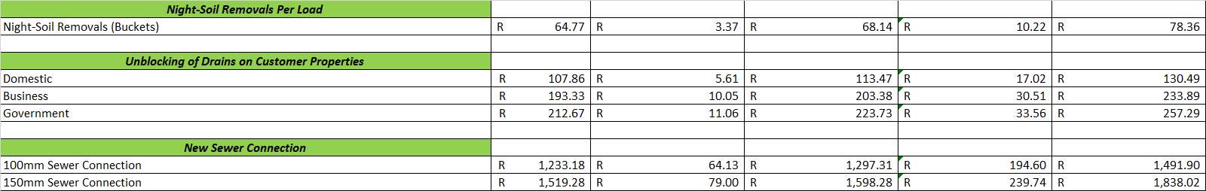

**3.0 Other Tariffs**

**3.1 Water infrastructure related tariffs**









**3.2 Water quality related tariffs**



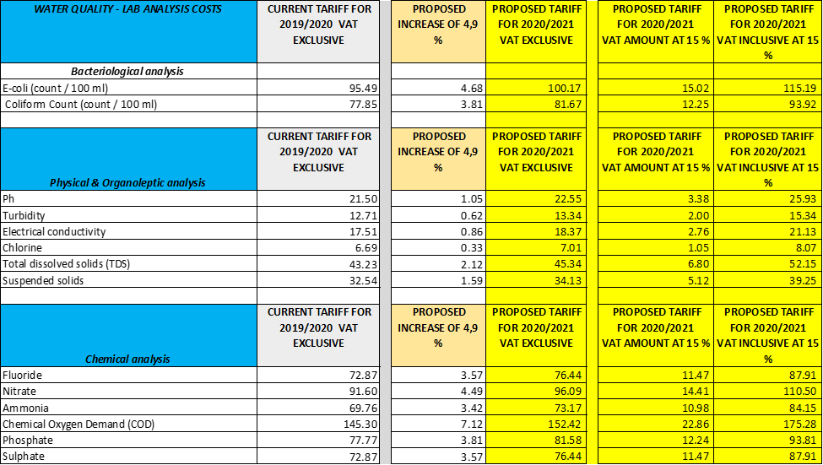

* 1. **Tariffs for other services rendered**







